Introduction and Theory

This document contains the instructions for using a micro bit to collect data in an environment to maximize a [indoor] plant’s health. We will pretend that we are inside a spaceship and want to grow some plants. The group of kids make up a team of scientists, each tasked with ensuring the health of a different plant assigned to them. We will be considering light, temperature, relative humidity, water, and soil health specific to a given plant. We will build each component step by step in chronological order.

We will begin by finding an optimal spot to place our plant:

1. We will use a light sensor to find a spot with optimal light conditions for the plant.
2. Next, we will check the temperature at this spot to see if any modifications need to be made to accommodate the plant. For example, we may place a fan nearby to cool down that section of the house.
3. We will also check the relative humidity of the air in this spot. Canada has lower humidity in the winter, so we may need to accommodate this as well. Again, we can look for a new location with higher humidity (like in a bathroom), or we can try to raise the humidity locally.

Now that we have found the perfect spot, we can use the micro bit to track the plant’s health. We will be concerned with checking the soil’s water level and how nutritious the soil is. We can also use the tool from our first step from time to time since all of those parameters are likely to change seasonally.

Each of these steps corresponds to one activity. Each activity will have a hardware part and a programming part.

This is a form to fill out about the chosen plant:

|  |  |
| --- | --- |
| Plant specifications | |
| Light |  |
| Temperature |  |
| Relative Humidity |  |
| Water (soil moisture) |  |
| Soil health | // maybe. Not sure how to track nutrients. Something to do with salt? |

* There will also be another form to track the results of an exercise as needed.

# **Theory**

## **Factors for a [indoor] healthy plant.**

1. **Light**

All plants need light to survive. They use light received from the sun (sunlight) or artificial light to make food. This process is called photosynthesis. Different types of plants need different brightness and amounts of sunlight. Some plants may prefer to be in sunlight for most of the day, while others are the healthiest, mostly in the shade. It’s essential to find a spot in the house that gets the right amount of light for your plant!

1. **Temperature**

Another important part of plant health is temperature. What temperature a plant prefers depends on where it originated from. All places on Earth have plants that naturally grow there. When we choose to grow a plant that originally grew in a different part of the world, we must consider what temperature it will be the healthiest in.

1. **Relative Humidity**

Relative humidity tells us how much water is in our surroundings compared to the amount of air. Each plant requires a different range of relative humidity. For example, tropical plants generally need more humidity than cacti.

1. **Water**

All living things need water to survive. Plants drink water through their roots. They need water for photosynthesis and also to absorb and move nutrients from the soil. Too much or too little water is bad for a plant’s health.

## **micro:bit**

### **Hardware**

A computer has inputs, a place to store and do something with information from the input, and a way to output things. A micro:bit is a tiny computer.

An input is a place where the micro:bit gets information from. We also call the information we get input.

An output a place where the micro:bit puts out information (like a screen or speaker). We call the information we want to share the output.

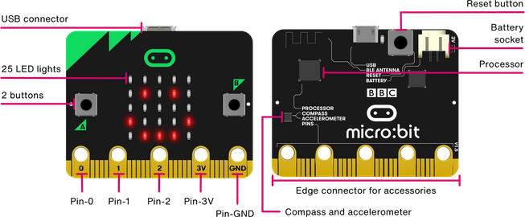Let’s explore the different parts of a micro:bit [relevant to our activites].

* **Reset Button**

Once you put in the batteries, the micro:bit is always on. Sometimes we want to reset the micro:bit. This is like restarting your computer or phone. We can do this by pressing the black circle button on the back.

* **Processor**

This is the brain of the micro:bit. This is where all the code we write goes. The micro:bit reads our code as instructions, so it knows what to do.

* **LED Lights**

There are 25 LED lights on a micro:bit. We can control which lights to turn on or off to create patterns. In this way, we can use the lights to output information. These LED lights are also light sensors, which means they input the amount of light shined on the micro:bit.

* **Buttons**

There are two buttons on the micro:bit. It is always waiting to see if anyone will press a button. If a button is pressed, then it sends a signal as an input. If we receive this signal, then we can make something happen!

* **Touch Logo**

The touch logo is the green symbol right above the LED lights. It is just like the buttons. The only difference is that we don’t need to press it. All we have to do is touch it!

* **Temperature sensor**

There is a temperature sensor inside the processor of the micro:bit. This keeps track of the temperature around the micro:bit and sends the micro:bit this information as input.

* **Pin**

We can connect different things to the pins located at the bottom of the micro:bit to have more inputs and outputs.

### **Software [coding]**

* **Blocks**

In MakeCode, each component is called a block. Each concept that is discussed in this section will correspond to a block in MakeCode.

[ USE FROM CODEMAKERS - THANKS BEA ]

ACTIVITIES

# Activity #1: Welcome to the spaceship

**Grades**: 3 - 5

**Length:** 30 minutes

**Description:** Define precision agriculture. Introduce the scenario for the following days.

**Materials**:

**Procedure:** After introducing yourself giving any auxiliary information about precision agriculture (e.g. women in computer science, CS at the University of Manitoba, etc.). Ask the class if they know what precision agriculture is.

What: precision agriculture is when we collect data about the environment to make decisions regarding a crop to maximize returns and preserve resources. (say this in your own words)

Why: precision agriculture helps us minimize waste and preserve resources, so it is good for the environment. It also helps us track a crop’s health to make sure it’s as healthy as possible.

Share this scenario:

“*For the next week, imagine that you are part of a team of scientists inside a spaceship. Imagine that your house or room is a spaceship. This team’s mission is to grow plants on the spaceship for food and to improve air quality. Each of you has a different type of plant that you have to make sure grows. You have limited supplies and space, so you want to make sure each plant is as healthy as possible. Together, we will be making and using precision agriculture tools to help us make the best decisions for our plants.*

*Let’s start by opening up our kits. Inside you will find a unique plant whose health you are in charge of! You will also find a sheet of paper that will give you information about the plant. This is important, so keep it safe. You will also find a microbit and some other things that I will explain later on in the week.”*

Ask them to ensure that the kit contains: one plant seed, a bag of soil, a little pot, an information sheet about the plant, a microbit, two nails, two alligator clip wires (one black, one red).

Now give the kids a chance to fill out an activity about their plant.

After they fill out this activity, they will introduce their plant to each other. Maybe explain your plant first. Something like: “Hi! I am Kajal, the sunflower expert. I will be making sure that we can grow sunflowers on our plant. [insert an interesting fact from the information sheet’ This is my sunflower, Sunny.”

Next, come up with a team name together. From now on, refer to this group by their team name. Let them decide where their spaceship is going.

# 

# Activity #2: The light sensor

**Grades**: 3 - 5

**Length:** 30 minutes

**Description:** Plot the information received from the light sensor onto the LED matrix. The number of LEDs that light up will correspond to the amount of light directed at the micro:bit. More lights = brighter spot. Potentially talk about how we can store this data to see how light intensity changes in a spot depending on the time of the year.

**Materials**: micro:bit

**Procedure:** After introducing yourself and the micro:bit giving any auxiliary information about precision agriculture (e.g. women in computer science, CS at the University of Manitoba, etc.) offer the class to play the following scenario:

“Welcome back, Team ___________. *[Do you remember what your mission is? Does anyone want to share it?] Imagine that you are part of a team of Computer Scientists inside a spaceship. Your job is to grow plants on the spaceship so that your team has something to eat and improve air quality. Each of you has a different type of plant that you have to make sure grows. You have limited supplies and space, so you want to make sure each plant is as healthy as possible.*

*Before we start planting, we need to find the correct place for our plant to grow. All plants need light to survive. They use light received from the sun (sunlight) or artificial light to make food. This process is called photosynthesis. Different types of plants need different brightness and amounts of sunlight. Some plants may prefer to be in sunlight for most of the day, while others are the healthiest, mostly in the shade. It’s essential to find a spot in the house that gets the right amount of light for your plant!*

*Today we will create a device that will help you track the amount of light in each part of the spaceship. Then you will use the device to find the right spot for your plant.”*

Use a diagram of a micro:bit or show a micro:bit to them. Point out the LED matrix and explain that each LED can be used as input and output. Each LED is a light sensor that returns a number ranging from 0 (dark) to 255 (really bright). We output this input by lighting up the LED lights depending on how dark it is.

Instructions for making the LED light tracker (picture at the end):

1. Connect the micro:bit to your computer using the USB port.
2. Open [https://makecode.micro:bit.org/#editor](https://makecode.microbit.org/#editor)
3. Tell them to name their light something cool. This will be the name of their project.
4. Click on basic and scroll down to find the forever component. Drag this component onto the main area.
   1. Explain that this component tells the micro:bit does wherever is inside the space over and over again forever.
5. Click on the LED section and grab the ‘plot bar graph of -- ‘ component. Place this inside the forever component.

Explain that this component tells the micro:bit to light up according to the light sensor inputs. If we get the number 255, then all the lights will turn on. If we get 0, then none of the lights will turn on. We need to tell this component what the highest input can be (255 in this case).

Play with the simulator on the left to show them how the plot bar works. Ask them to predict what will happen if you make the sunlight the brightest. You can do this by interacting with the yellow circle on the top left of the simulation. What if you make it the lowest?

1. Click on the three dots next to the purple download button.
2. Click on pair device.
3. Once paired, click on download to micro:bit.
4. Cover the microbit with your hand to see if the bar graph works.
5. Done!

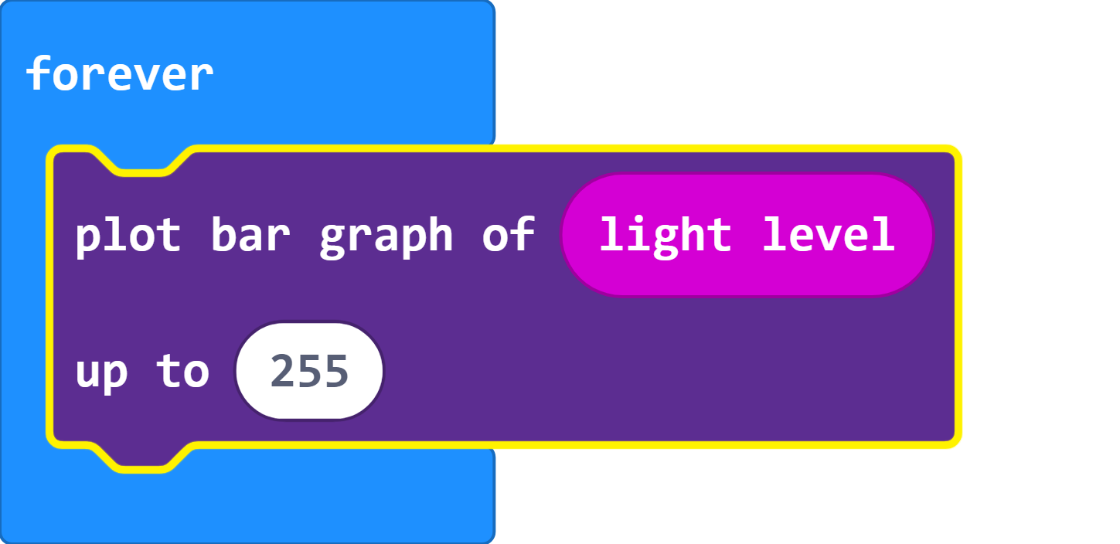

Make sure that they do this part safely and with adult supervision.

Instruct them to unplug the micro:bit and explore the spaceship to find the darkest and the brightest spots. Find a location that lights up exactly x amounts of lights. Remember to come back are share any interesting results with your teammates.

The last step is to see how much light their plant needs (from the info sheet) and find several possible right spots. In the next activity, we will narrow down our choices.

If someone wasn’t able to find a spot: encourage the team to brainstorm ideas to help create the light for this plant. Does it need more light? They can place a lamp nearby. Does it require less light? Can they shade the plant somehow (possibly using other plants)? Don’t give them the answers. Prompt them with questions.

# Activity #3: The temperature sensor

**Grades**: 3 - 5

**Length:** 30 minutes

**Description:** Display the room temperature. As homework, keep track of how it changes throughout the day for each spot (if they want).

**Materials**: micro:bit

**Procedure:** After introducing yourself and the micro:bit giving any auxiliary information about precision agriculture (e.g. women in computer science, CS at the University of Manitoba, etc.) offer the class to play the following scenario:

“Welcome back, Team ___________. *[Do you remember what your mission is? Does anyone want to share it?] Imagine that you are part of a team of Computer Scientists inside a spaceship. Your job is to grow plants on the spaceship so that your team has something to eat and improve air quality. Each of you has a different type of plant that you have to make sure grows. You have limited supplies and space, so you want to make sure each plant is as healthy as possible.*

*Yesterday, you selected some spaceship areas that get the right amount of sunlight for your plant. Another important part of plant health is temperature. What temperature a plant prefers depends on where it originated from. All places on Earth have plants that naturally grow there. When we choose to grow a plant that originally grew in a different part of the world, we must consider what temperature it will be the healthiest in.*

*Today you will create a device that will help you track the temperature in each part of the spaceship. Then you will use the device to narrow down your list of spots base on what kind of climate is most suitable for your plant.”*

Explain: micro:bits have a temperature sensor. It inputs the temperature to the microbit. We will be using the led matrix to display this input (temperature). We don’t want the temperature always to be showing, so we will use the shake input to decide when to show the temperature.

Instructions for making the temperature tracker (picture at the end):

1. Connect the micro:bit to your computer using the USB port.
2. Open [https://makecode.micro:bit.org/#editor](https://makecode.microbit.org/#editor)
3. Tell them to name their temperature tracker something cool. This will be the name of their project.
4. Click on input and scroll down to find the on-shake component. Drag this component onto the main area.

Explain that this component tells the micro:bit does wherever is inside the space if someone shakes the microbit.

1. Click on the basic section and grab the ‘show number ‘ component. Place this inside the shake component.

Explain that this component tells the micro:bit to display a number on the LED output. Explain that we have to tell it which number to show.

1. Click on input and scroll down to find the temperature component. Drag this component inside the slot of the show number component.
2. Use the simulator to show them how we expect the micro:bit to behave.
3. Click on the three dots next to the purple download button.
4. Click on pair device.
5. Once paired, click on download to micro:bit.
6. Shake the micro:bit to see if it works.
7. Done!

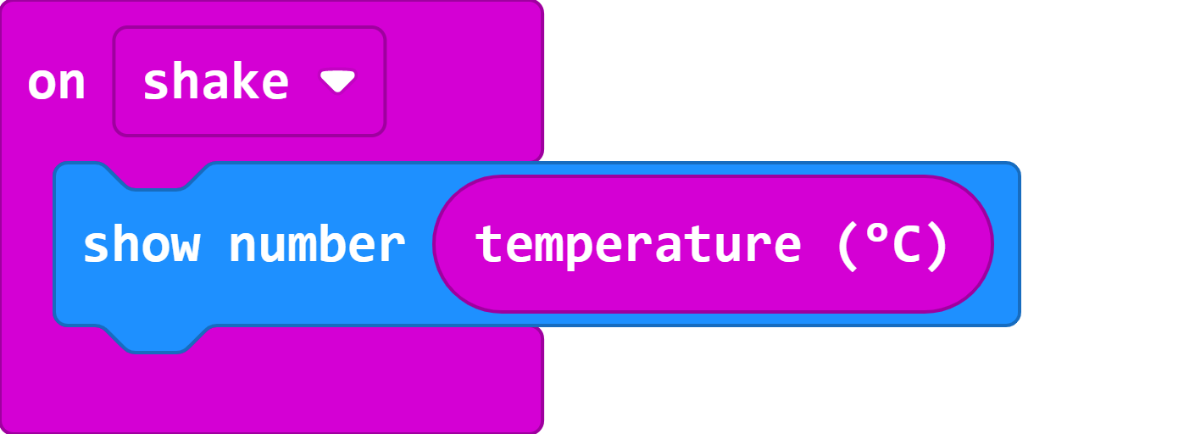

Make sure that they do this part safely and with adult supervision.

Instruct them to unplug the micro:bit and explore the spaceship to find the warmest and the coolest spots (safely and with supervision). Remember to come back are share any interesting results with your teammates.

The last step is to see what temperature their plant requires. Go to the list of possible spots and make sure the temperature is healthy for the plant. If it is NOT, then cross off that spot from your list.

If none of the spots remain for a kid after the last step, brainstorm with the entire team to find solutions. Should they use artificial light (lamp), add shade to the spot, place a fan nearby to cool down the temperature etc. Don’t give them the answers. Prompt them with questions.

# Activity #4.5: Plant your seed

**NOTE: DO THIS ACTIVITY AT THE END OF ACTIVITY 4 OR THE START OF ACTIVITY 5. WHICHEVER WORKS OUT.**

**Grades**: 3 - 5

**Length:** 15 minutes

**Materials**: seed, soil, pot, stickers, markers/paint/crayon/glitter whatever they have

**Description:** Guide the students through putting soil in their pot and planting the seed. Give them some time to decorate their pot if you have time. Otherwise, let them know that they can decorate their plant (on their own time).

# 

# Activity #5: The water sensor

**Grades**: 3 - 5

**Length:** 1 hour

**Description:** Check soil’s moisture level to make sure that the plant is not getting under/over watered.

**Materials**: micro:bit, two nails, two alligator clip wires, a plant - more specifically - soil, water

**Procedure:** After introducing yourself and the micro:bit giving any auxiliary information about precision agriculture (e.g. women in computer science, CS at the University of Manitoba, etc.) offer the class to play the following scenario:

“Welcome back, Team ___________. *[Do you remember what your mission is? Does anyone want to share it?] Imagine that you are part of a team of Computer Scientists inside a spaceship. Your job is to grow plants on the spaceship so that your team has something to eat and improve air quality. Each of you has a different type of plant that you have to make sure grows. You have limited supplies and space, so you want to make sure each plant is as healthy as possible.*

*All living things need water to survive. Plants drink water through their roots. They need water for photosynthesis and also to absorb and move nutrients from the soil. Too much or too little water is bad for a plant’s health. Today you will create a device that will help you track the soil moisture. Then you will use the device to make sure your plant is getting the right amount of water..”*

Explain: We can connect different things to the pins located at the bottom of the micro:bit to have more inputs and outputs.

Instructions for making the moisture sensor (pictures at the end):

1. Connect the red alligator clip to the 5v pin on one end and one of the nails on the other end.
   1. This wire will input moisture and nutrient information from the soil to the microbit.
2. Connect the black alligator click to the GND pin one end to the other nail on the other end.
   1. Explain ground in simple terms
3. Connect the micro:bit to your computer using the USB port.
4. Open [https://makecode.micro:bit.org/#editor](https://makecode.microbit.org/#editor)
5. Tell them to name their light tracker something cool. This will be the name of their project.
6. Click on basic and scroll down to find the ‘on button A pressed’ component. Drag this component onto the main area.

Explain that this component tells the micro:bit to do wherever is inside the space every time button A is pressed. So the micro:bit is always listening to see if someone presses button A.

1. Click on the LED section and grab the ‘plot bar graph of -- ‘ component. Place this inside the on button A pressed component.
   1. Explain that this component tells the micro:bit to light up according to the solid moisture input. If we get the number 1023, then all the lights will turn on. If we get 0, then *none* of the lights will turn on. We need to tell this component what the highest input can be (1023 in this case).
2. Click on the basic section and grab a pause component. Set this to 5000ms (5 seconds). Click on the basic section and grab the clear screen component. Place this under the pause component. This will display the plotted graph for 5 seconds and then clear the screen.
3. Click on the three dots next to the purple download button.
4. Click on ‘pair device’.
5. Once paired, click on download to micro:bit.
6. Press button A the micro:bit to see if it works.
7. Put the nails inside the plant and press button A to see the moisture level of this plant).
8. If the value of the bar graph is too low then water your plant. If it’s completely lit up, you may have watered the plant too much. Use the water sensor to guide how much to water the plant.

[Photos on next page]

